HM-10 Bluetooth-4.0 V2 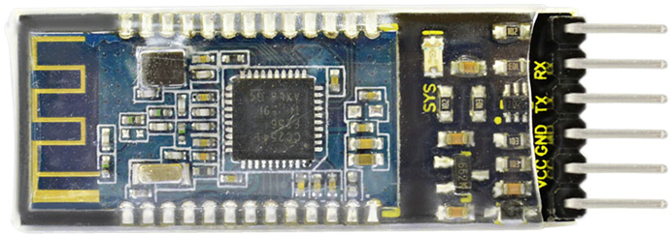

Introduction
HM-10 Bluetooth-4.0 V2 adopts TI CC2541 chip, configuration space of 256Kb . It supports AT command. Users can modify working mode (master/slave), baud rate, device name, paring password, etc.

Specification
1. Bluetooth protocol: Bluetooth Specification V4.0 BLE
2. No byte limit in serial port Transceiving
3. In open environment, realize 100m ultra-distance communication with iphone4s
4. USB protocol: USB V2.0
5. Working frequency: 2.4GHz ISM band
6. Modulation method: GFSK(Gaussian Frequency Shift Keying)
7. Transmission power: -23dbm, -6dbm, 0dbm, 6dbm, can be modified by AT command.
8. Sensitivity: ≤-84dBm at 0.1% BER
9. Transmission rate: Asynchronous: 6K bytes
Synchronous: 6k Bytes
10. Security feature: Authentication and encryption
11. Supporting service: Central & Peripheral UUID FFE0, FFE1
12. Power consumption: Auto sleep mode, stand by current 400uA~800uA, 8.5mA during transmission.
13. Power supply: 5V DC
14. Working temperature: –5 ~ +65 Centigrade
15. Weight: 3.2g
16. Size: 46*17*5mm

Circuit Connection

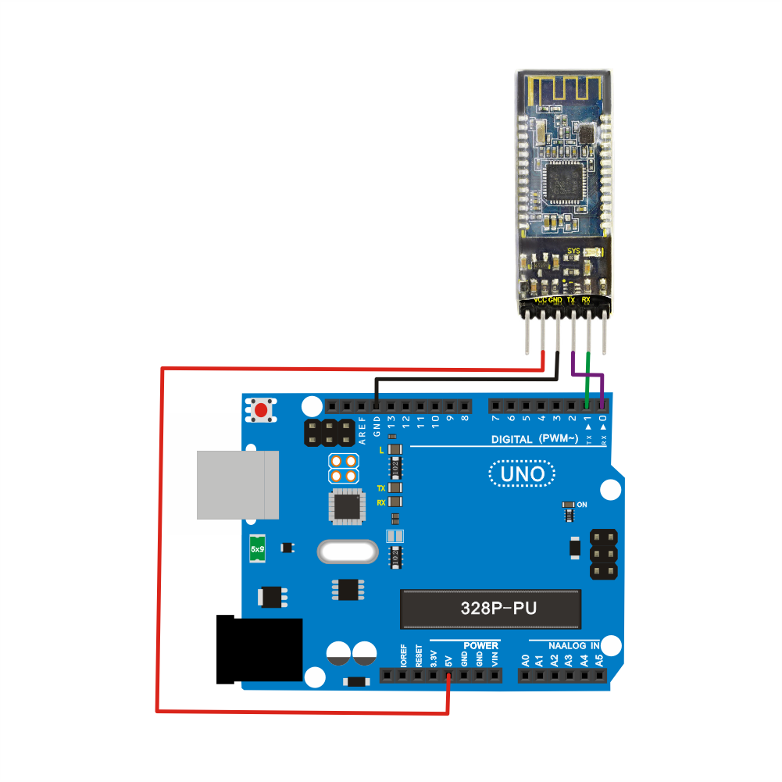
Sample Code
///////////////////////////////////////////////////////////////
int val;
int ledpin=13;
void setup()
{
Serial.begin(9600);
pinMode(ledpin,OUTPUT);
} void loop()
{ val=Serial.read();
if(val=='a')
{
digitalWrite(ledpin,HIGH);
delay(250);
digitalWrite(ledpin,LOW);
delay(250);
Serial.println("keyestudio");
}
}
///////////////////////////////////////////////////////////////

Result
Open APP HC-COM, click search device, select the device, device is connected; the LED on the Bluetooth module is on. Enter “a” in HC-COM, click “send”, Bluetooth APP will display keyestudio. Every time HC-COM sends an “a”, the Pin13 LED on the main board blinks once.

